# Application Logo

## variations and analysis

### Company logo:



This is our minimalistic logo, based on a footprint as our application name is a play on the common phrase carbon footprint.

### App store icon:

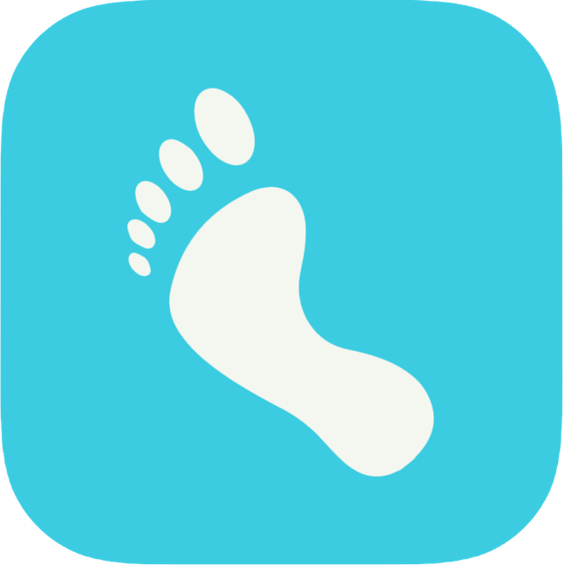

This is our app store icon. This incorporates our colour pallet, using our brightest colour to attract attention.